Parish Links

School Masses in the Parish
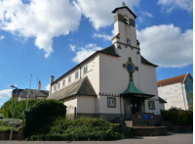

Once a month at the 10am Sunday Mass, our school leads readings, prayers and singing in our parish, Our lady, Star of the Sea, at St. Joseph’s Church, Stavordale Road, Weymouth. The children prepare for the mass in school and then school staff help them serve at church. Information about the school masses are published in the weekly parish newsletter. A paragraph relating to our work at school also features in the letter on a weekly basis.

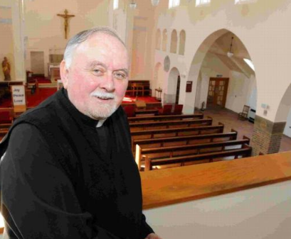
Come and meet Father Stephen

